Pedigree Analysis

Introduction
A pedigree is a diagram of family relationships that uses symbols to represent people and lines to represent genetic relationships. These diagrams make it easier to visualize relationships within families, particularly large extended families. Pedigrees are often used to determine the mode of inheritance (dominant, recessive, etc.) of genetic diseases. A sample pedigree is below.
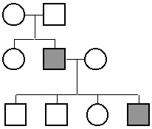
In a pedigree, squares represent males and circles represent females. Horizontal lines connecting a male and female represent mating. Vertical lines extending downward from a couple represent their children. Subsequent generations are therefore written underneath the parental generations and the oldest individuals are found at the top of the pedigree.
If the purpose of a pedigree is to analyze the pattern of inheritance of a particular trait, it is customary to shade in the symbol of all individuals that possess this trait.
In the pedigree above, the grandparents had two children, a son and a daughter. The son had the trait in question. One of his four children also had the trait.
In the exercises below, assume that the trait in question is a genetic disease or abnormality. We will learn patterns of inheritance that have the following modes of inheritance:
autosomal dominant
autosomal recessive
X-linked recessive

Developing Conclusions About Different Modes of Inheritance

Autosomal Dominant
1. The pedigree below is for a genetic disease or abnormality. We do not yet know if it is dominant or recessive. We will determine if it is possible that the trait is autosomal dominant. If the trait were dominant, we could use the following designations:
A = the trait (a genetic disease or abnormality, dominant)
a = normal (recessive)
a) Assume for the moment that the trait is dominant (we don't know yet). The pedigree shows that three of the individuals have the recessive (normal) phenotype and one individual has the dominant (abnormal) phenotype. Write the genotype of the affected (abnormal) individual next to her symbol in the pedigree below. If you only know one of the genes (letters), use a "?" for the unknown letter. If possible, write the genotype of the three recessive individuals next to their symbols. As you attempt to write the genotypes, keep in mind that the pedigree may not be possible for a dominant trait; it may not be possible to write the genotypes.
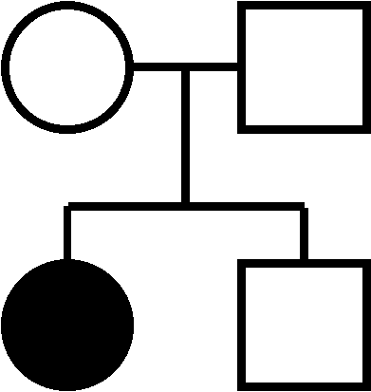
b) Is it possible that the pedigree above is for an autosomal dominant trait?
c) Write the genotypes next to the symbol for each person in the pedigree below assuming that it is for a dominant trait.
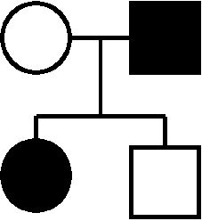
d) Is it possible that this pedigree is for an autosomal dominant trait?
e) What can you conclude from these two examples about the parents of a child that has a dominant characteristic? Write your conclusion on the answer sheet (question 1).
2. We will determine if the pedigree below can be for a trait that is autosomal dominant. Use "A" and "a" as you did for the pedigrees above.
a) Write the genotype of each individual next to the symbol.
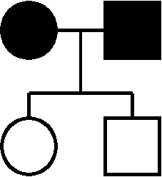
b) Is it possible that this pedigree is for an autosomal dominant trait?
c) In conclusion, can two individuals that have an autosomal dominant trait have unaffected children? Write your conclusion on the answer sheet (question 2).

Autosomal Recessive
3. We will determine if the pedigree below can be for a trait that is autosomal recessive. Use the following designations:
A = normal
a = the trait (a genetic disease or abnormality)
a) Assuming that the trait is recessive, write the genotype of each individual next to the symbol.
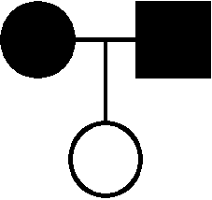
b) Is it possible that the pedigree above is for an autosomal recessive trait?
c) Assuming that the pedigree below is for a recessive trait, write the genotype next to the symbol for each person.
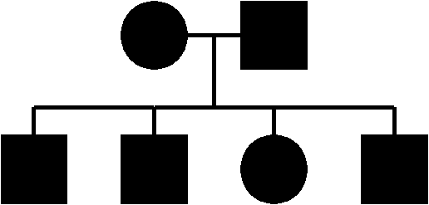
d) Is it possible that this pedigree is for an autosomal recessive trait?
e) If a trait is autosomal recessive, what can you conclude about the children if both parents are affected? Write your conclusion on the answer sheet (question 3).
4. We will determine if the pedigree below can be for a trait that is autosomal recessive. Use "A" and "a" as you did for the previous example.
a) Write the genotype of each individual next to the symbol.
b) Is it possible that this pedigree is for an autosomal recessive trait?
c) If a trait is autosomal recessive, what can you conclude about the children of two parents that are not affected? Write your conclusion on the answer sheet (question 4).
5. We will determine if the pedigree below can be for a trait that is autosomal recessive.
a) Write the genotype of each individual next to the symbol.
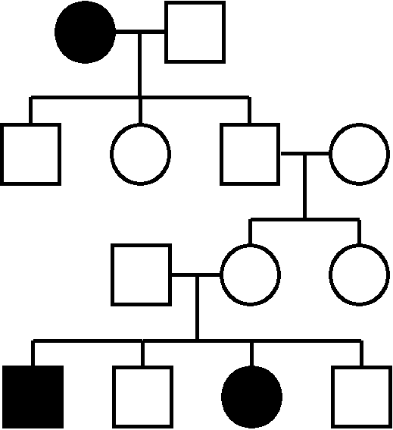
b) Is it possible that this pedigree is for an autosomal recessive trait?
c) In this pedigree, two generations have been skipped. What can you conclude about recessive traits skipping generations (is it possible or not)? Write your conclusion on the answer sheet (question 5).

X-Linked Recessive
The conclusions that you made for autosomal recessive traits apply to X-linked traits. In this exercise, we will work on some additional conclusions because males have only one X chromosome and females have two.
6 and 7. We will determine if the pedigrees below can be for a trait that is X-linked recessive. Use the following designations:
X^{A} = normal
Xª = the trait (a genetic disease or abnormality)
Y = Y chromosome (males only)
a) Write the genotype of each individual next to the symbol.
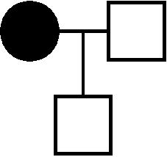
b) Is it possible that the pedigree above is for an X-linked recessive trait?
c) Write the genotype next to the symbol for each person in the pedigree below.
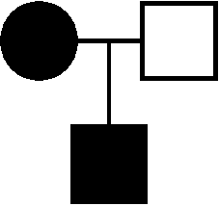
d) Is it possible that this pedigree is for an X-linked recessive trait?
e) Write the genotype next to the symbol for each person in the pedigree below.
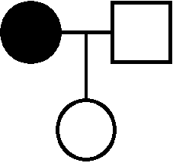
f) Is it possible that this pedigree is for an X-linked recessive trait?
g) Write the genotype next to the symbol for each person in the pedigree below.
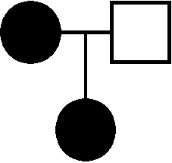
h) Is it possible that this pedigree is for an X-linked recessive trait?
i) What can you conclude about the children of mothers affected with an X-linked recessive characteristic? Write your conclusion on the answer sheet (questions 6 and 7).
j) What can you conclude about the father of an affected female?
8. We will determine if the pedigree below can be for a trait that is X-linked recessive. We will continue to use the designations "X^{A} and Xª".
a) Write the genotype of each individual next to the symbol.
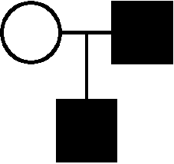
b) Is it possible that this pedigree is for an X-linked recessive trait?
c) Which parent did the son get the Xª gene from? In general, you cannot use a pedigree to tell if father-to-son transmission occurred because the sun might have received the gene from his mother.
d) What can you conclude about father-to-son transmission of X-linked traits? Write your conclusion on the answer sheet (question 8).
9. We will determine if the pedigree below can be for a trait that is X-linked recessive.
a) Write the genotype of each individual next to the symbol.
b) Is it possible that this pedigree is for an X-linked recessive trait?
c) What can you conclude about the children if both parents are affected with an X-linked recessive trait?

d) How does this conclusion compare with the one you made earlier if about both parents being affected by an autosomal recessive trait?

e) Do the conclusions that you made for autosomal recessive traits apply to X-linked recessive traits? Write your conclusion on the answer sheet (question 9).

10a. If a genetic disease is X-linked recessive, what is the phenotype of a female that has only one disease allele (Xª)?
b. What is the phenotype of a male with one disease allele?
c. What can you conclude about the number of males that would have the disease compared to the number of females? Write your conclusion on the answer sheet (question 10).

Application of Pedigree Analysis
The conclusions about inheritance (above) can be used to help analyze pedigrees. For each pedigree below, tell if the trait can be autosomal dominant, autosomal recessive, and X-linked recessive. If the pedigree cannot fit a mode of inheritance, tell why.
Pedigree A
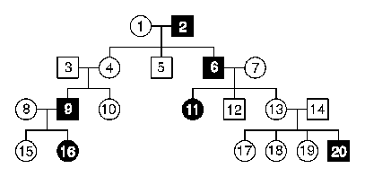
Pedigree B
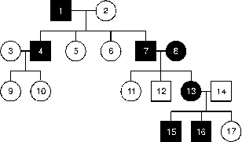
Questions 10 through 15- Answer with either "yes" or "no." If you answer no, explain why.
11) Can pedigree A be autosomal dominant? To answer this question, go back and look at your conclusion for autosomal dominant traits (question 1e).
12) Can pedigree B be autosomal dominant?
13) Can pedigree A be autosomal recessive? To answer this question go back and look at your conclusion for autosomal recessive traits (question 3e).
14) Can pedigree B be autosomal recessive?
15) Can pedigree A be X-linked recessive? To answer this question, go back and look at your conclusion for X-linked recessive traits (questions 6i and 6j).
16) Can pedigree B be X-linked recessive?

